Neelima Institute of Medical Sciences
Anurag University
Post Graduate Fee Structure – 2025- 26

Seat Matrix & Fee Details:
The Fees for the Post Graduate courses are approved by the Fee fixation committee, this committee formed as per the Telangana State Private Universities act 11 of 2018.
S.No | Departments | Fee Structure
S.No | Departments | MQ1 | MQ2
1 | Clinical  (All Broad Specialties) | 25,50,000/- | 3 times of MQ1 Category
2 | Para Clinical  (Pharma, Path, SPM, Forensic, Micro) | 5,30,000/- | 3 times of MQ1 Category
3 | Pre Clinical  (Anatomy, Physiology, Biochemistry) | 2,00,000/- | 3 times of MQ1 Category

Other Fees:
Fee Particulars | Payable (Once/Yearly) | Amount in Rs/-
College Caution Fee (Refundable after 3 years) | Once | 10,000.00
Sports & Games Fee | Once | 5,000.00
Library Fee | Once | 55,000.00
Administration Fee | Once | 50,000.00
Total |  | 1,20,000.00

Bank Details :
The bank details for remitting the Tuition Fee through RTGS are as follows. In the case of payment through demand draft, it is to be drawn in the favor of Neelima Institute of Medical Sciences payable at Ghatkesar
NAME: | NEELIMA INSTITUTE OF MEDICAL SCIENCES
BANK: | STATE BANK OF INDIA
BRANCH: | Ghatkesar
ACCOUNT NO.: | 41601964037
IFSC CODE: | SBIN0020450

“Kindly note that ‘Gayatri Educational and Cultural Trust’ will appear as the beneficiary name for RTGS transactions.”
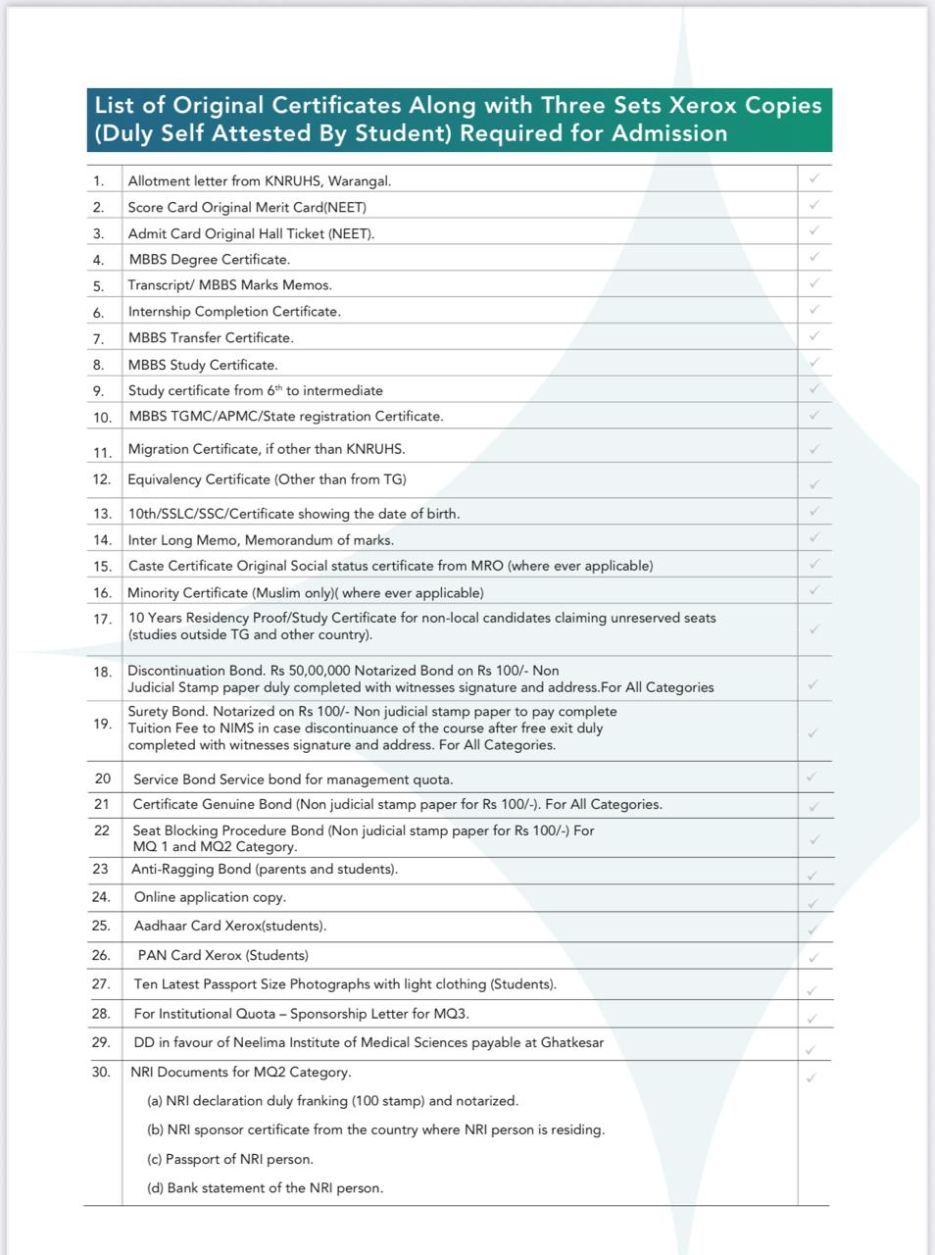


KALOJI NARAYANA RAO UNIVERSITY OF HEALTH SCIENCES, TELANGANA
MEDICAL PG DEGREE/DIPLOMA ADMISSIONS UNDER MANAGEMENT QUOTA FOR THE AY 2025-26
MEDICAL PG DEGREE CLINICAL & NON-CLINICAL SEAT MATRIX
Course | NEELIMA 2025-26
Course | MQ1 (LOC) | MQ1 (UR) | MQ2 | MQ3
GM | 1 | 2 | 0 | 1
PAED | 1 | 2 | 0 | 1
ANES | 1 | 2 | 0 | 1
PM | 1 | 2 | 1 | 0
DVL | 1 | 2 | 0 | 1
RD | 1 | 2 | 0 | 1
PSY
RT
EM
TM
HA
NM
GS | 0 | 1 | 1 | 0
ORTHO | 0 | 1 | 0 | 1
OPTHAL
ENT
OBG | 1 | 2 | 0 | 1
ANATO
PHYSI
BIO | 1 | 2 | 1 | 0
PATH | 1 | 2 | 1 | 0
MICRO
PHARMA | 1 | 2 | 1 | 0
FM
SPM | 1 | 2 | 1 | 0

